

29 March 2021

**BANK OF JAMAICA HOLDS POLICY RATE**

Bank of Jamaica (BOJ) announces its decision to hold the policy interest rate (the rate offered to deposit-taking institutions on overnight placements with BOJ) unchanged at **0.50 per cent per annum.**

Bank of Jamaica has kept the policy rate at the historic low level of 0.50 per cent based on its assessment that inflation will generally continue to remain within the target of 4.0 per cent to 6.0 per cent over the next two years. The Bank’s accommodative monetary policy posture is also aimed at supporting a recovery in economic activity in Jamaica.

The economic outlook for Jamaica remains uncertain in the context of the ongoing COVID-19 pandemic but BOJ remains cautiously optimistic, particularly in light of the commencement of the domestic vaccination programme against the COVID-19 virus. The Bank will continue to assess and monitor new developments as they emerge and take appropriate actions, as needed.

**Inflation**

Annual headline inflation at February 2021, as reported by the Statistical Institute of Jamaica, declined to 3.8 per cent, from 4.7 per cent at January 2021. The inflation rate for February 2021 is below the lower limit of the Bank’s target of 4% – 6% but continues to reflect success in keeping inflation low (see Chart below). The decline in inflation during the month largely reflected a fall in prices for vegetables and starchy foods, emanating from an improvement in agricultural supplies.

Underlying or core inflation, which measures the change in prices excluding agricultural food and fuel prices, was 3.5 per cent at February 2021, in line with the outturn at January 2021.

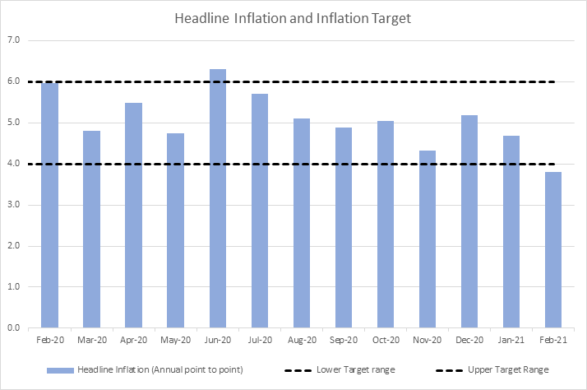

**Bank of Jamaica’s current assessment remains broadly in line with our projections communicated in February 2021. Inflation will average around 5.0 per cent over the next two years and will, for the most part, track within the target range of 4.0 per cent to 6.0 per cent.** The inflation forecast anticipated that, while domestic food price inflation would fall, oil price inflation would accelerate. A normalisation in domestic GDP growth, accompanied by some imported inflation, was projected to support core inflation over the next eight quarters. Additionally, the outlook for core inflation contemplated the effects of one-off adjustments in selected regulated prices.

The risks to the inflation forecast are balanced. Factors that could cause the inflation rate to be higher than forecasted include stronger than anticipated increases in international oil and grains prices. However, inflation could be lower than forecasted given stronger than anticipated reversals in the prices for agriculture items.

**Economic Activity**

Bank of Jamaica is forecasting a contraction in the economy in the range of 10.0 per cent to 12.0 per cent in FY2020/21 before partially recovering with growth in the range of 4.0 per cent to 8.0 per cent in FY2021/22. A projected decline in real GDP for the March 2021 quarter is expected to be mainly reflected in *Hotels & Restaurants*, *Transport, Storage & Communication* and *Other Services*. The overall decline for the quarter, which is expected to be smaller than the contractions of the previous three quarters, is largely based on the adverse, albeit receding, impact of the global COVID-19 pandemic on travel and entertainment activities.

The Bank’s current assessment suggests that the risks to the GDP forecast are balanced. The main risk over the forecast period is the continued adverse impact of COVID-19 on the Jamaican economy, given the increased number of confirmed cases in the island recently and accompanying tighter stringency measures. However, on the upside, there is the possibility that approved vaccines are distributed at a faster than anticipated rate, which could lead to relaxed lockdown and physical distancing measures, thus supporting stronger economic activity.

# Monetary Policy

While the impact of the Covid-19 virus has recently led to an increase in the stringency of measures in Jamaica to control its spread, there remains optimism about future GDP growth as vaccination programmes have commenced both locally and globally. Bank of Jamaica has maintained an accommodative monetary policy stance aimed at supporting a speedy economic recovery once this crisis has passed. Bank of Jamaica remains committed to ensuring that inflation remains low and stable, within its target and, at the same time, is prepared to take all necessary actions to ensure that Jamaica’s financial system remains sound. **The Bank intends to maintain this monetary policy stance until there are clear signs that economic activity in Jamaica is returning to pre-COVID-19 levels.**

The date of the next policy decision announcement, to be issued by the Bank’s newly formed Monetary Policy Committee, is 18 May 2021.

* 30 –